Ponce Martin 10371381 Date 20/08/2014

Family name Given name Student number

**ENS1161 Computer Fundamentals**

**Test 3**

(a) Find the value of M = x (y’ + yz) , if (x, y, z) = (0, 1, 1).

M = 0(0 + 1 • 1)

= 0(0 + 1)

= 0 • 1

= 0

(b) List the combinations of (x, y, z) for which G(x,y,z) = x (y’ + z) + x’yz will be

equal to 1.

(x, y, z) = (0,1,1)

= (1,0,0)

= (1,0,1)

= (1,1,1)

(c) Write a Boolean expression for the output L of the circuit shown:



L = A’B + AB’C + BC’

(d) Use de Morgan's laws to express Q = ( x’ + xyz )’ as a sum of products.

Q = (x’ + xyz)’

= x(x’ + y’ + z’)

= xx’ + xy’ + xz’

= xy’ + xz’

(e) Expand P(x, y, z) = x'y + yz into a **complete** sum of products.

P = x’y(z + z’) + xz(y + y’)

= x’yz + x’yz’ + xyz + xy’z

(f) Draw a circuit corresponding to the function J(x, y, z) = x’y + xy’z

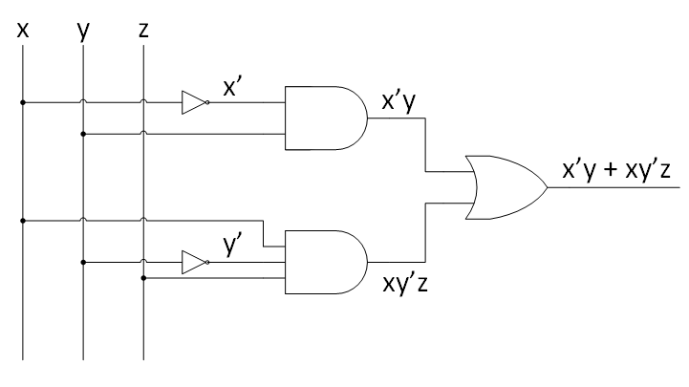

[ 1 + 2 + 2 + 2 + 2 + 1 = 10 marks ]